What Is Random Walk Theory?
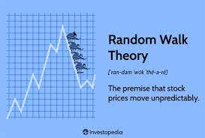
Random walk theory suggests that changes in asset prices are random. This means that stock prices move unpredictably, so that past prices cannot be used to accurately predict future prices. Random walk theory also implies that the stock market is efficient and reflects all available information.

A random walk challenges the idea that traders can time the market or use technical analysis to identify and profit from patterns or trends in stock prices. Random walk has been criticized by some traders and analysts who believe that stock prices can be predicted using various methods, like technical analysis.

KEY TAKEAWAYS
- Random walk theory states that stock prices are random, so that past movement or trend of a stock price or market cannot be used to predict its future movement.
- Random walk theory implies that it’s impossible to beat the market without assuming additional risk.
- Random walk theory considers fundamental analysis undependable due to the often-poor quality of information collected and its ability to be misinterpreted.
- Random walk theory also suggests that investment advisors add little or no value to an investor’s portfolio.
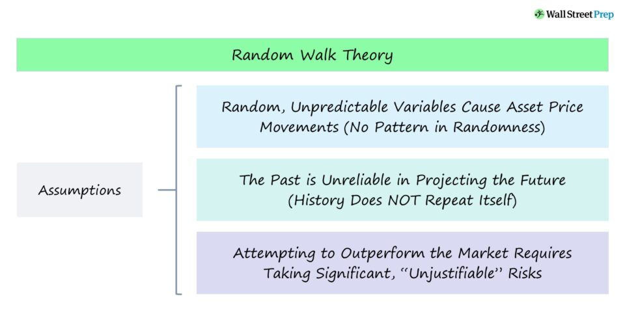

Understanding Random Walk Theory
Economists had long argued that asset prices were essentially random and unpredictable—and that past price action had little or no influence on future changes. This, indeed, was a key assumption of the efficient market hypothesis (EMH). Random walk theory is based on the idea that stock prices reflect all available information and adjust quickly to new information, making it impossible to act on it.
The theory thus has important implications for investors, suggesting that buying and holding a diversified portfolio may be the best long-term investment strategy.

Random walk theory was popularized by Malkiel in his 1973 book, A Random Walk Down Wall Street.
In the book, Malkiel argues that trying to time or beat the market, or using fundamental or technical analysis to predict stock prices, is a waste of time and can lead to underperformance. Instead, he claims that investors are better off buying and holding a broad index fund.

While random walk theory has been met with critics who believe that there are, in fact, ways to predict stock prices and outperform using various techniques, it remains a widely accepted theory in the world of financial economics. By accepting that stock prices are unpredictable and efficient, investors can focus on long-term planning and avoid making rash decisions based on short-term market movements. Ultimately, random walk theory reminds investors of the importance of remaining disciplined, patient, and focused on their long-term investment goals.

Assumptions
The random walk theory economics assumes that stock prices follow a random and unpredictable pattern. It says that future price movements cannot be reliably predicted based on past prices or any other information, as stock prices adjust instantaneously to new information, rendering past data irrelevant.
This theory contends that stock price changes are independent and identically distributed, meaning that each price change is unrelated to the previous change and has an equal likelihood of being up or down.
Furthermore, the theory assumes that all market participants have equal access to information and that prices fully reflect all available information. This theory’s assumptions underscore the challenges of beating the market consistently through technical or fundamental analysis. It emphasizes the importance of diversification, long-term investing, and understanding the limitations of prediction in financial markets

What is Random Walk Theory?
Random Walk Theory says that in an Efficient market, the stock price is random because you can’t predict, as all information is already available to everyone. How they will react depends on their financial needs and choices. An efficient market, on the other hand, is a market with transparency and general information; future earnings are taught in the stock price.
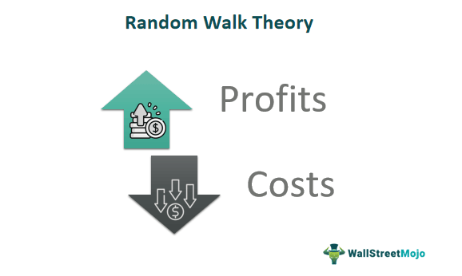

In an inverse situation of the random walk theory economics is when a buyer is buying a stock, then they are buying it based on any information; that information is also available to the seller who is selling the stock. This is the efficient market, where everyone has got the information, and still, they do what is good for them according to their personal choice.
- Random Walk Theory states that stock prices in an efficient market are random due to unpredictability and financial needs. The reaction depends on financial requirements and choices.
- Random Walk Theory suggests investing in fund managers to manage random stock prices, as luck may not sustain and an alpha return may not be achieved in the next year.
- Passive investors believe in Random Walk Theory, as fund managers’ performance fails to outperform the index.

Random Walk Theory
The Random Walk Theory asserts that stock market prices evolve according to a random walk and, thus, cannot be predicted. It’s grounded in the belief that the stock market is very efficient, with each successive price reflecting all known information about that stock and the market. Consequently, stock price changes are driven by unforeseen events, making them unpredictable.
Several key ideas stem from the Random Walk Theory:
- Future stock prices are not based on past prices: If stock prices follow a random walk, using past prices to predict future prices would be futile. This challenges technical analysis, which largely depends on studying past stock price movements.
- Short-run price movements are random: In the short term, you can’t reliably predict whether stock prices will go up or down. Prices react to news and events, which are themselves unpredictable.
- The market is efficient: This ties into the Efficient Market Hypothesis (EMH), which argues that at any given time, stock prices already reflect all available information. There are three forms of EMH:
  - Weak form: All past market prices and data are already incorporated into stock prices, making technical analysis ineffective.
  - Semi-strong form: All publicly available information, not just past prices, is incorporated into stock prices. This suggests neither technical nor fundamental analysis can reliably boost returns.
  - Strong form: All information, both public and private, is fully reflected in stock prices. This would imply that even insider information can’t help an investor achieve superior returns.
- It’s hard to consistently outperform the market: If stock price movements are unpredictable and the market efficiently prices in all information, then consistently beating the market becomes a challenging task. Thus, many proponents of the theory advocate for passive investment strategies, such as buying and holding index funds, over active stock-picking.
While the Random Walk Theory has many proponents, especially among academics, it’s not universally accepted. Some investors believe they can achieve superior returns either through analyzing market patterns or through other strategies. However, numerous empirical studies have shown that it’s extremely difficult for active fund managers to consistently outperform the market, lending some weight to the theory.

Random Walk Theory Explained
Random Walk Theory is practical and has proven correct in most cases. The theory says that if Stock Prices are random, we need to waste money and hire fund managers to manage our money.

In a world where markets are efficient, the only way to earn a return is with the market itself. In this way, the cost of fund managers can be avoided, and you will end up earning the same return or maybe more because fund managers charge fees for funds they manage.
The belief has grown stronger that no fund manager can beat benchmark year on year, so instead of paying fees to managers, it’s better to invest passively.

Example #1
LMN garments company’s stock is trading at $100. Suddenly there was news of the fire in the factory, and Stock Price fell by 10%. The next day when the market started, the stock price fell by another 10%. Hence, what Random Walk Theory says is that they fell on the fire day was due to the news of the fire, but they fell on the next day was not on the news of the fire again. Due to any updated news on fire, say, an exact number of fabrics burned that caused the fall on the next day.
Therefore, Stock Prices are not dependent on each other. Each day stock reacts to various news and is independent of each other.
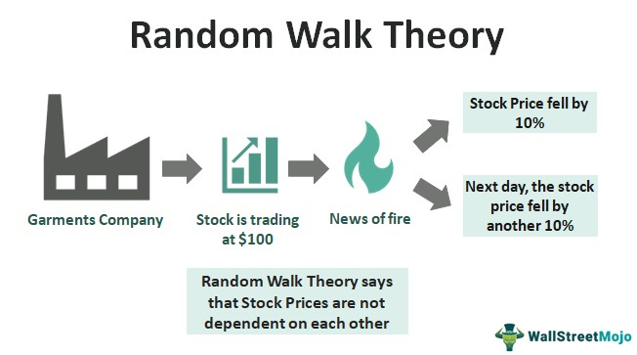

Example #2
The stock price of Apple Inc. opened at $190.02 on March 21, 2019. Its price rose to $195.09 during the closing bell. On March 22, the very next day, it lost all the value it gained the previous day and did not even gain the momentum back to $195 till April 3 2019.
Subsequently later in April 2019, the share price breached the $200 mark and lost all gained value in May and lost the value in June.

How Does It Apply to Stocks?
Let us understand in detail how this theory applies to the stock market and stocks through the explanation below.
- Stock movement, as described by random walk theory finance, is unpredictable. The easiest way to earn money in this world is to invest in stocks and wait for them to grow. Hence, this theory says that if the movement of stock price had been so easy to predict, then everyone would have made a fortune by now. Not all who invest in stocks end up winning. Then how are people losing money?
- Random Walk criticizes Technical Analysis. This theory heavily criticizes fundamental analysis and technical analysis. Technical analysis says that history repeats. Thereby, stock prices follow the trend that they have shown in the past. Random Walk believes that the stock price was as per the information available in the past. Each stock price is independent of the other.
- It means today’s stock price is not dependent on what the stock price was yesterday. Yesterday’s price was based on available information, and today, the stock price is based on available information. Everyone has access to all the information. Insider information is not included in this theory.
- Random Walk Theory is based on the weak-form efficient market hypothesis, which states that all the available information is already taught in the stock price. Suppose there is any prediction of future earnings, then that earning’s present value is also taught in the stock price. The trading is between informed buyers and informed sellers, and it depends on what they would like to do. So ultimately, it is random.

Implications
Since we now understand the basics, assumptions, and examples of the random walk theory economics, let us now delve deeper into the implications of this theory through the discussion below.
- Stock Prices are random, so instead of spending money on Fund Managers, one should buy ETFs or spend on stocks in the exact quantity of an index.
- Technical analysis or fundamental analysis doesn’t work in predicting the stock price as it is impossible to predict it.
- Stock prices are independent; today’s stock price has no relation to yesterday’s stock price.
- Markets are efficient, information is readily available, and informed decisions are always taken.

Advantages
Let us understand the advantages of the random walk theory finance through the points below.
- Efficient Market Perspective: The Random Walk Theory asserts that stock prices rapidly adjust to new information, ensuring that market prices accurately reflect all available information. This viewpoint highlights the efficiency of financial markets in processing and incorporating information, aiding investors in making informed decisions.
- Balanced Investment Approach: By assuming that stock price movements are unpredictable, the theory encourages a diversified and balanced investment strategy. Investors are urged to focus on long-term goals rather than attempting to time the market, ultimately reducing the risk associated with trying to predict short-term price movements.
- Mitigated Illusion of Patterns: The theory dispels the illusion of discernible patterns in stock price movements. Recognizing that prices follow a random and independent trajectory helps investors avoid falling prey to misleading patterns that might lead to poor investment decisions, promoting a more rational approach to investing.

Disadvantages
Despite the advantages mentioned above, there are a few disadvantages that are as discussed below.
- Markets are not entirely efficient. Information asymmetry is there, and many insiders react much earlier than other investors due to the information edge.
- In many cases, stock prices have shown a trend year on year.
- One lousy news affects a stock price for several days, even months.
Criticisms of Random Walk Theory
- The main criticism of random walk theory is that it oversimplifies the complexity of financial markets, ignoring the impact of market participants’ behavior and actions on prices and outcomes.
- Prices can also be influenced by nonrandom factors, such as changes in interest rates or government regulations, or less ethical practices like insider trading and market manipulation.

- Market technicians argue that historical patterns and trends can, in fact, provide useful information about future prices, challenging the theory’s assertion that past prices are not informative. They claim that technical analysis can intuit market psychology to identify. Other investors have also challenged the theory by pointing to examples of successful stock pickers, such as Warren Buffett, who have consistently outperformed the market over long periods of time by looking closely at company fundamentals.
- Another critique is that a random walk implicitly assumes that all investors have the same information, when in reality, some investors have access to more and better information than others (such as large, institutional investors). Indeed, information asymmetries have been found in real-world markets that cause markets to be inefficient.

Does random walk theory apply only to stocks?
No. While it is most commonly applied to the stock market, it can also be applied to other financial markets such as the bond, forex, and commodities markets, among others.

Is random walk theory correct?
Random walk theory is widely debated among financial economists and market practitioners. While some agree with its basic tenets, others have challenged its assumptions and have proposed alternative theories of how and why prices move. Some have pointed out instances where stock prices do not follow a random walk, such as during bubbles or flash crashes. In these cases, prices may be driven more by emotional factors than by randomness.

The Bottom Line
Random walk theory claims that stock prices move randomly and are not influenced by their history. Because of this, it is impossible to use past price action or fundamental analysis to predict future trends or price action. If markets are indeed random, then markets are efficient, reflecting all available information.

The random walk theory maintains that individual stocks do not move in any discernible pattern and therefore their short-term future movements cannot be predicted in advance.

Since the market indexes overall tend to rise over the long-term, adherents of random walk theory would be likely to recommend investing in a passively-managed diversified index fund.

